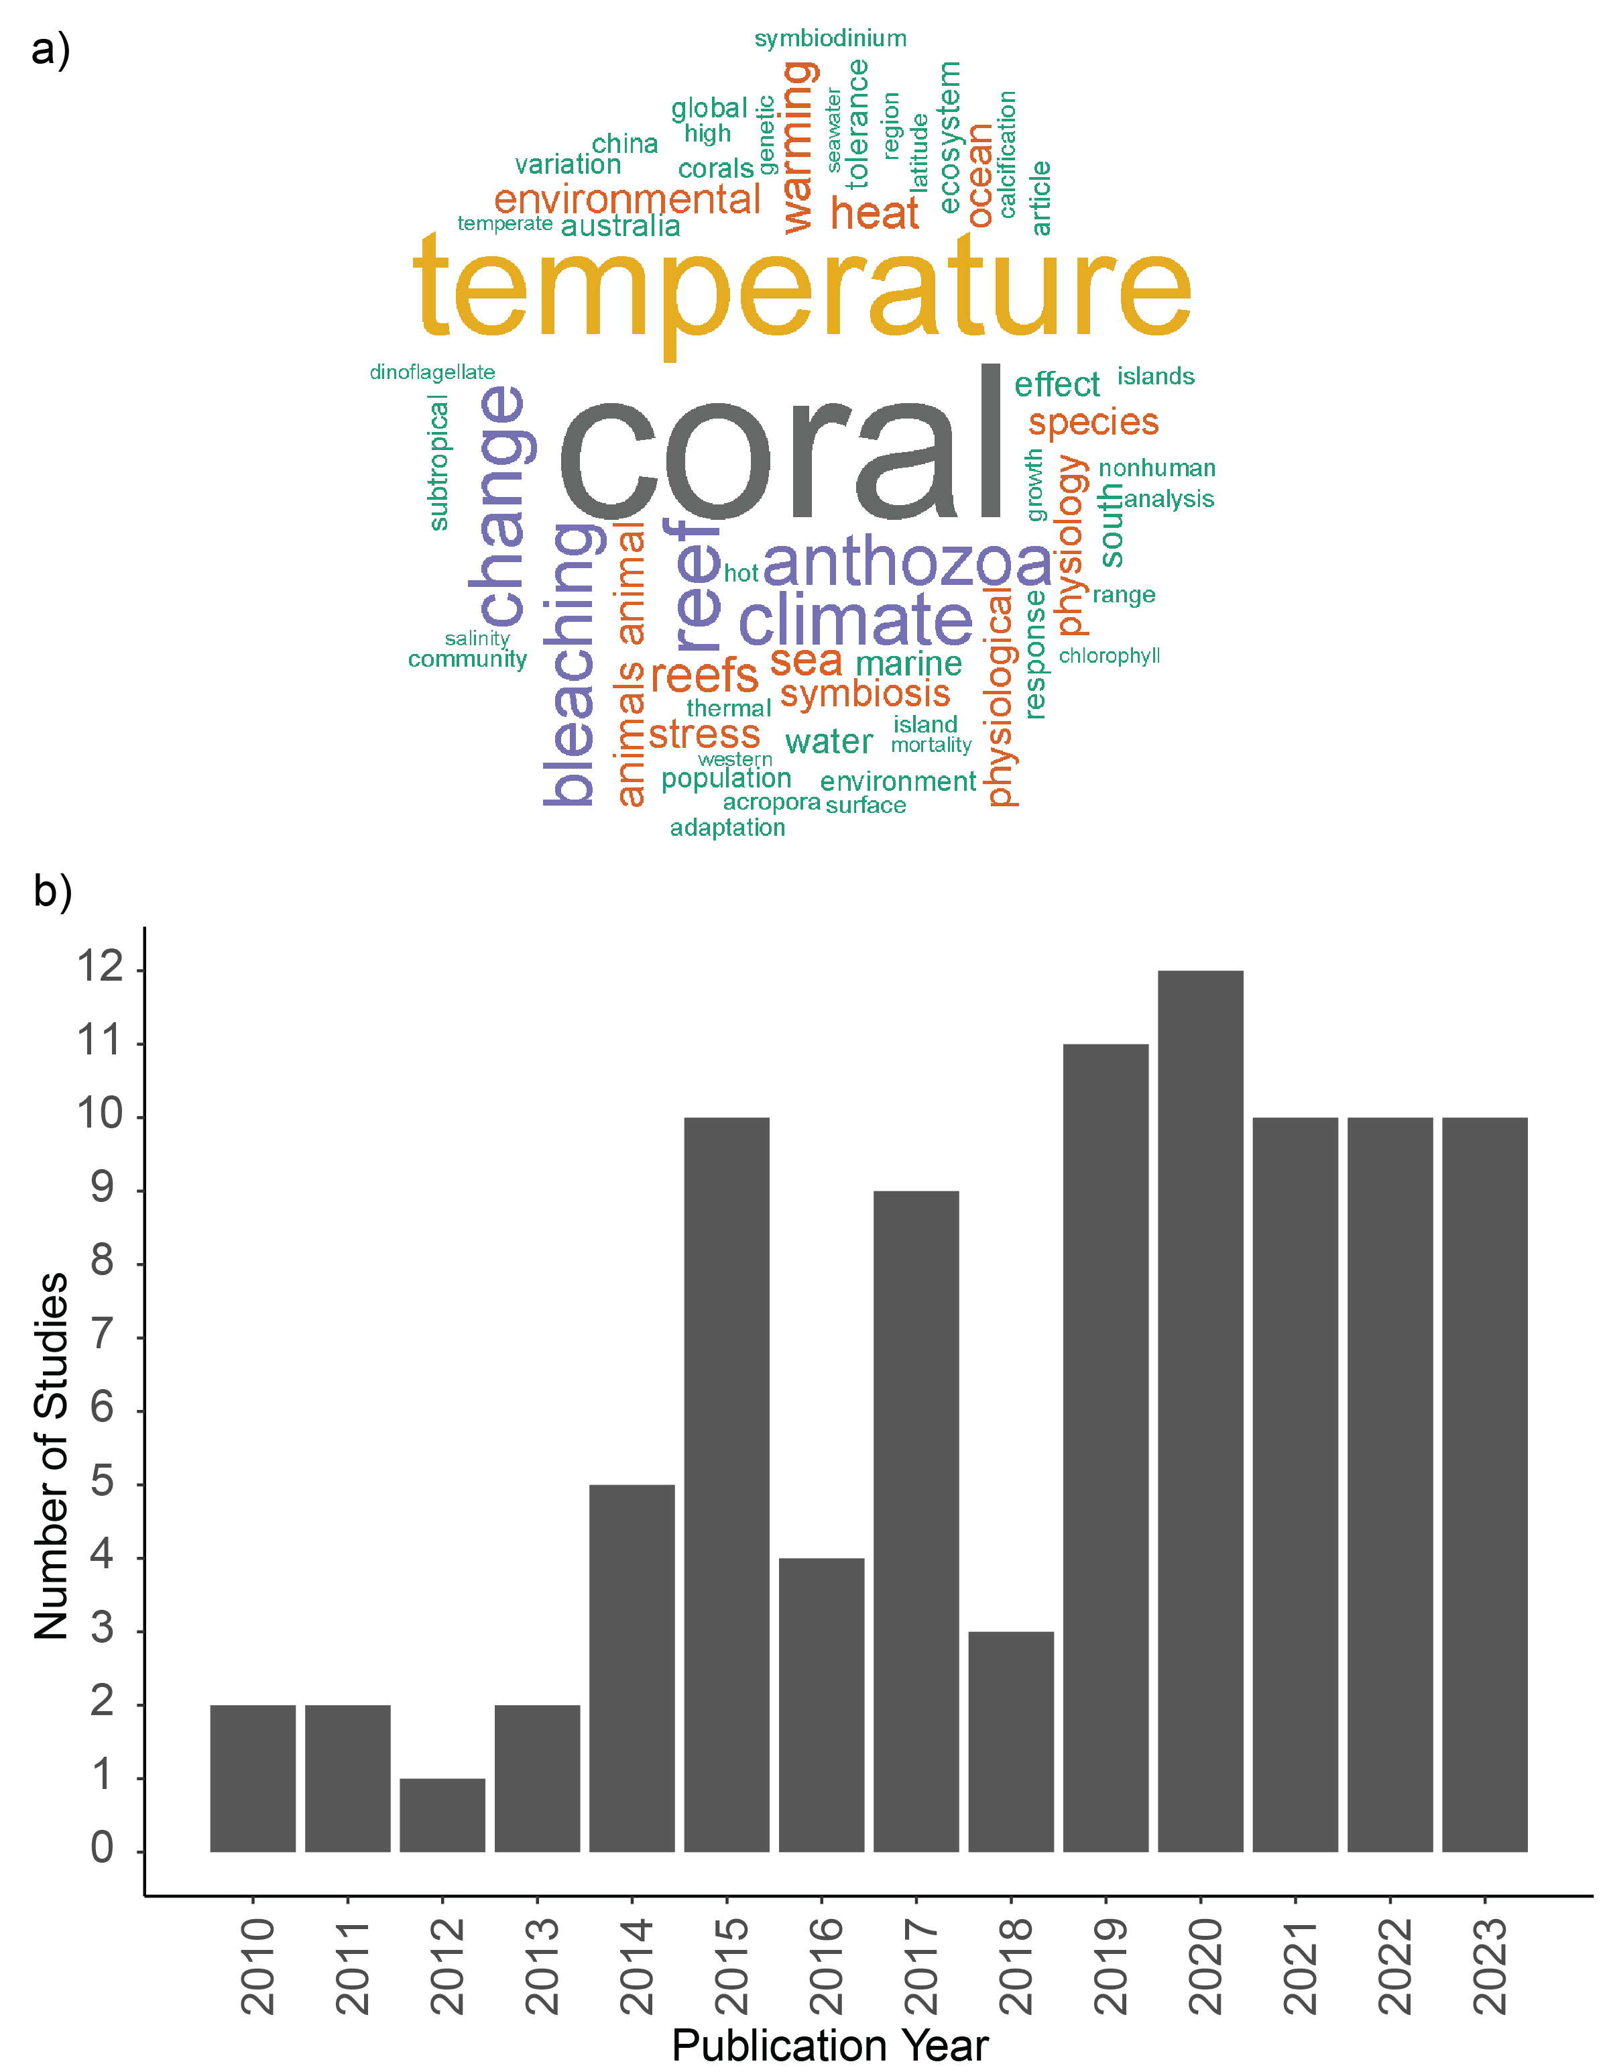
Figure 4 a) Word cloud featuring keywords appearing at least 10 times from the literature included in this systematic map. b) The number of publications by year.

